
BVRIT HYDERABAD College of

OBJECT ORIENTED PROGRAMMING JAVA

MINI PROJECT

TEAM DETAILS:
TEAM SIZE: 3 TEAM MEMBERS:
M.Medha Sree - 24WH1A05K2 G.Sai Sruthi- 24WH1A05H3
L.Sanjana Devi –24WH1A05G5
BRANCH : CSE

SECTION: C

Project

Stack visualizer— Java GUI Application

Title

Stack Visualizer Using Java Swing

Problem Statement

To develop a Java Swing desktop application that visually simulates stack operations such as Push, Pop, Peek, Display, and Clear, using an object-oriented approach with stack logic implemented in a separate class.

GitHub Link
https://github.com/NareshCSE/Java24CSEC/blob/main/24WH1A05G5/programs_java.docx

Two Test Cases

TEST CASE 1: Push & Peek

Input:
Push -> 60
Push -> 10
Push -> 10
Push->100
Push->25
Push->80
Peek

Peek result: Top = 80

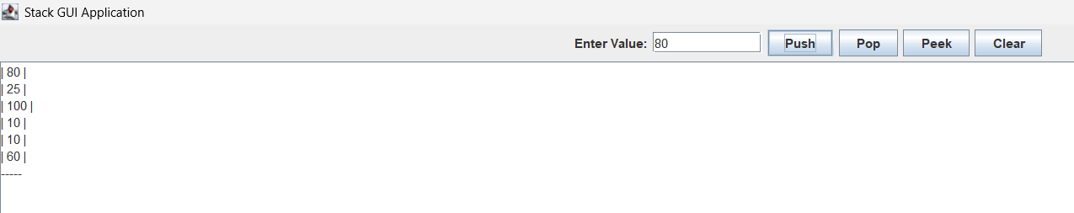

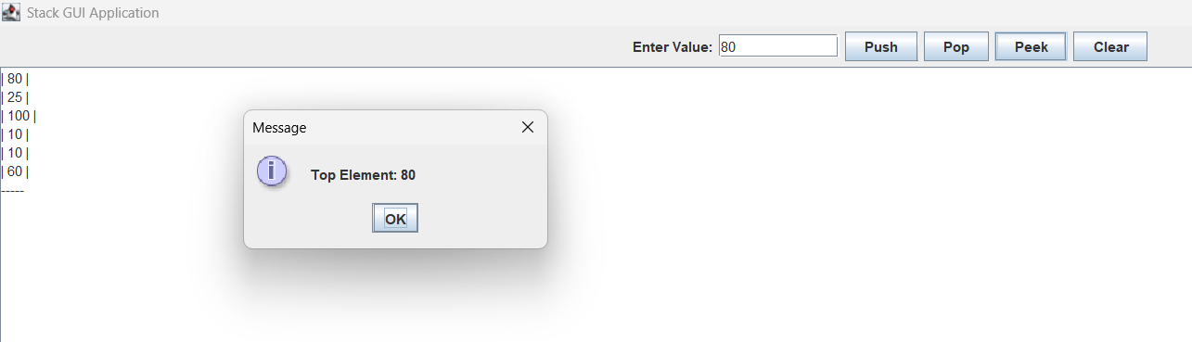

TEST CASE 2: Pop & Underflow
Input:
Pop
Pop
Pop
Pop
Pop

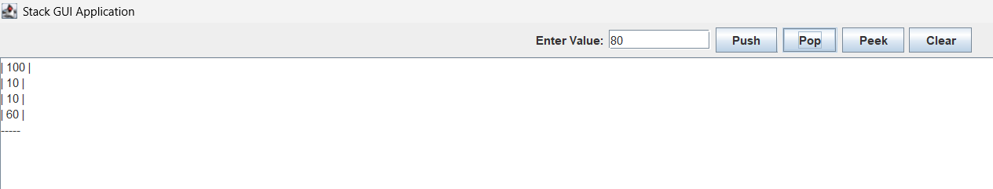

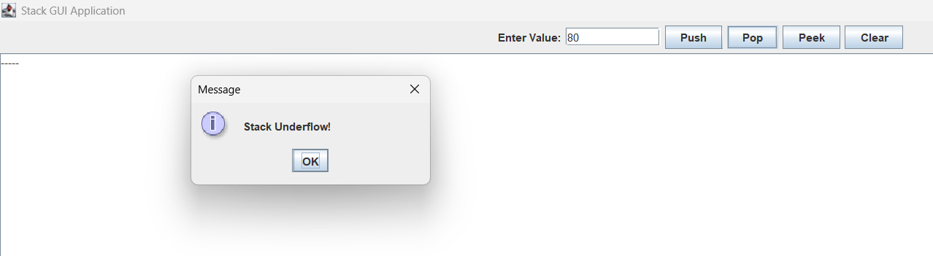

Expected Output:

Pops: 80,25,100,10,10,60
Seventh pop → Underflow

CODE:

package Javaprograms;

import javax.swing.*;
import java.awt.*;
import java.awt.event.*;

public class miniproject extends JFrame {

static class Stack {
private int maxSize;
private int top;
private int[] stackArray;

public Stack(int size) {
maxSize = size;
stackArray = new int[maxSize];
top = -1;
}

public boolean push(int value) {
if (isFull()) return false;
stackArray[++top] = value;
return true;
}

public Integer pop() {
if (isEmpty()) return null;
return stackArray[top--];
}

public Integer peek() {
if (isEmpty()) return null;
return stackArray[top];
}

public boolean isEmpty() {
return (top == -1);
}

public boolean isFull() {
return (top == maxSize - 1);
}

public int[] getArray() {
return stackArray;
}

public int getTop() {
return top;
}
}

private Stack stack;
private JTextField inputField;
private JTextArea displayArea;

public miniproject() {
super("Stack GUI Application");

stack = new Stack(10);

inputField = new JTextField(10);
displayArea = new JTextArea(10, 20);
displayArea.setEditable(false);

JButton pushBtn = new JButton("Push");
JButton popBtn = new JButton("Pop");
JButton peekBtn = new JButton("Peek");
JButton clearBtn = new JButton("Clear");

pushBtn.addActionListener(e -> {
try {
int value = Integer.parseInt(inputField.getText());
if (stack.push(value)) {
updateDisplay();
} else {
JOptionPane.showMessageDialog(this, "Stack Overflow!");
}
} catch (Exception ex) {
JOptionPane.showMessageDialog(this, "Please enter a valid number.");
}
});

popBtn.addActionListener(e -> {
Integer popped = stack.pop();
if (popped == null) {
JOptionPane.showMessageDialog(this, "Stack Underflow!");
} else {
updateDisplay();
}
});

peekBtn.addActionListener(e -> {
Integer top = stack.peek();
if (top == null) {
JOptionPane.showMessageDialog(this, "Stack is Empty!");
} else {
JOptionPane.showMessageDialog(this, "Top Element: " + top);
}
});

clearBtn.addActionListener(e -> {
while (!stack.isEmpty()) stack.pop();
updateDisplay();
});

JPanel panel = new JPanel();
panel.add(new JLabel("Enter Value:"));
panel.add(inputField);
panel.add(pushBtn);
panel.add(popBtn);
panel.add(peekBtn);
panel.add(clearBtn);

setLayout(new BorderLayout());
add(panel, BorderLayout.NORTH);
add(new JScrollPane(displayArea), BorderLayout.CENTER);

setSize(400, 300);
setDefaultCloseOperation(JFrame.EXIT_ON_CLOSE);
setVisible(true);
}

// Update visual stack display
private void updateDisplay() {
displayArea.setText("");
int top = stack.getTop();
int[] arr = stack.getArray();

for (int i = top; i >= 0; i--) {
displayArea.append("| " + arr[i] + " |\n");
}
displayArea.append("-----\n");
}

public static void main(String[] args) {
new miniproject();
}
}

